The data used to visualize information on the population of infants living a certain distance from health clinics was compiled from various database sources. These include Health.io for health clinic locations, country-specific population data from WorldPop, travel time to health facilities from Mapbox, and administrative boundaries from the Database of Global Administrative Areas (GADM). Population, travel time, and clinic locations can also be found via OpenStreetMap. The first step to complete this analysis was to import the data into QGIS in the proper formats. Raster layers containing global infant population and transportation times to health clinics were imported and clipped by mask layer to the extent of the admin 0 (country boundaries) vector layer. Admins 1 and 2 were also imported as vector layers and added to the map for further analysis later in the process. Infant population was imported as two separate layers divided by male and female infants. After all necessary layers were imported, the GDAL Raster Calculator was used to calculate the total population of infants living 30 minutes away from known health clinic locations. Clipped raster layers containing travel time, female infant population, and male infant population were added as input layers A, B, and C, respectively. The equation to calculate population by travel time in GDAL numeric syntax ((A>30)*((B)+(C))) ensured that both female and male populations contributed to the total sum of infants per square kilometer, while also filtering for travel time. The Zonal Statistics tool was used to calculate the infant population in each Admin 2 polygon in the clipped country, specifically by sum within each boundary. The zonal statistics table was exported to Microsoft Excel for tidying. The final sum by polygon product includes the country, state (Admin 1), district (Admin 2), and sum (infant population by district).
In order to recreate a custom workflow whose input can be altered depending on user preferences and output resembles the original map, a Processing Model was generated that takes unique inputs and results in zonal statistics with a corresponding visualization. The required inputs include both rasters (global travel time, global male infant population, global female infant population) and shapefiles (administrative boundaries and health clinic locations). Rasters are clipped by the Admin 0 vector. The clipped outputs transition to input for the GDAL Raster Calculator that calculates infant population by the user’s chosen travel time threshold. Finally, population by district boundaries result from the Zonal Statistics tool. This Processing Model workflow is pictured below for reference:
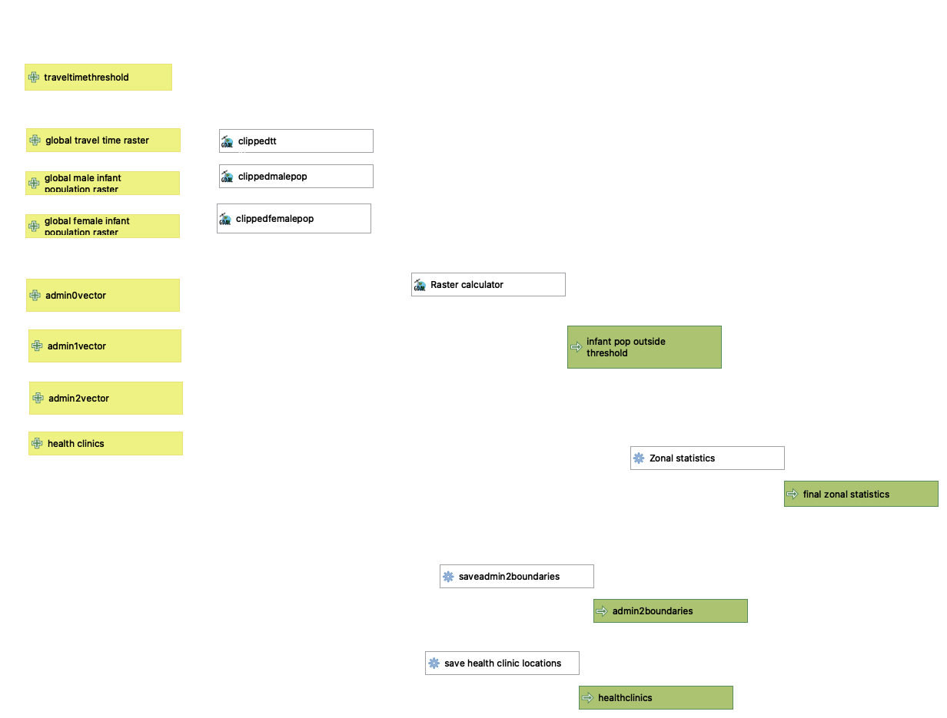
The Processing Model was used to recreate the original analysis on India using a 45-minute travel time threshold instead of 30 minutes, and again on Somalia with 30- and 45-minute thresholds. The tables for these analyses show that the total number of infants requiring mobile vaccination decreases when the travel time threshold increases.
